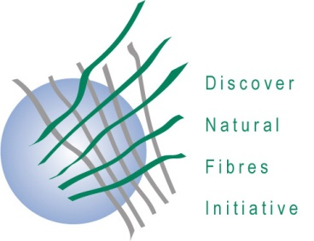

DNFI Membership Commitment

…………………..
Date

……………………………………………………………..
Name of company
………………………………………………………………
Address
…………………………………….…

On behalf of (enter name of company or organisation), I, (enter first name, last name), hereby commit to membership in the Discover Natural Fibers Initiative (DNFI). With this commitment we acknowledge that:
- The DNFI is a platform for the natural fibers stakeholder community to facilitate the exchange of knowledge and experience among members to advance the common interests of all natural fibres.
- The aim of the DNFI is to work together to promote all natural fibers in the face of competition from manmade fibers, to raise awareness of natural fibers advantages, to share knowledge about sustainability, to exchange information on innovative agricultural and industrial technologies which allow the development of multidirectional applications for natural fibers, and to share information on improving the economic conditions of cultivation and industrial production of natural fiber products.
- The DNFI is a joint effort of all types of natural fibers organizations in facing the current economic, environmental and social challenges; by working jointly, DNFI members will have the strongest influence on improvement of the position of natural fibers.
- The DNFI is based on the principles of international collaboration. The DNFI includes agricultural and industry members, and the membership relies on a spirit of mutual trust and open dialogue as well as on collaboration among multiple stakeholders for the achievement of its goals. We will commit to this spirit and shared values in any communication about the DNFI membership.
(enter name of company or organisation) is also committed to improving natural fibre industries so as to ensure a sustainable future for everyone involved in the long term.
As a Member of DNFI, we shall enjoy the following benefits:
- The right to attend all member meetings;
- Eligibility to serve as an officer;
- The ability to take part in international fairs or conferences within DNFI pavilions or sessions,
- The ability to have and share the newest information, including statistics related to natural fibres,
- The ability to propose of collaboration ideas with experts representing different types of natural fibres,
- The rights to ask for advice in terms of natural fibre agriculture, industry and innovation,
- The opportunity to have the company’s logo displayed on the DNFI website, as well as to have DNFI’s logo displayed on company’s website,
- The ability to share updated information about natural fibres and events dedicated to natural fibres via the DNFI website
- Access to the DNFI’s projects and publications.

Signature: _____________________________________________________________
Title: ______________________________________ Date: _____________________

