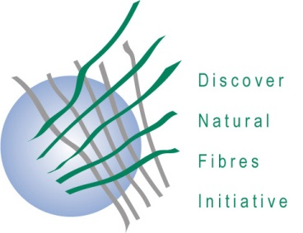
DNFI Innovation in Natural Fibres Awards 2020

The deadline for award submissions is
11 September 2020

Application form

Innovative processes/procedures

A maximum of two extra pages (for a total of three pages) of information and two photographs may be included with this submission.
This Form should be sent to DNFI, e-mail: Secretariat@DNFI.org

Title of the Submission

Description of the process or procedure

Degree to which the innovation has been implemented or may be implemented

Level of innovation

Potential for developing new markets or uses for natural fibres.

Contact information for the Submitter:
Name
Position
Company or Institution
Physical Address
E-Mail address
Phone

