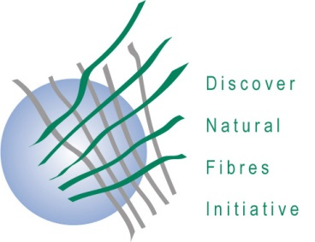
DNFI Innovation in Natural Fibres Awards 2020

The deadline for award submissions is
11 September 2020

Application form

Innovative research and science

A maximum of two extra pages (for a total of three pages) of information and two photographs may be included with this submission.
This Form should be sent to DNFI, e-mail: Secretariat@DNFI.org

Title of the Submission

Description of the research and the associated science

Degree to which the innovation may lead to implementation of products or services using natural fibres

Level of innovation

Potential for developing new markets or uses for natural fibres.

Contact information for the Submitter:
Name
Position
Company or Institution
Physical Address
E-Mail address
Phone

