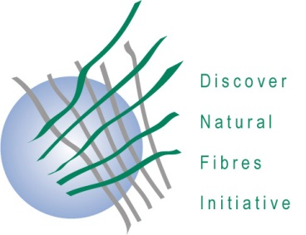
DNFI Innovation in Natural Fibres Awards 2023

The deadline for award submissions is
8 September 2023

Application form: Innovative products/components or applications

A maximum of two extra pages (for a total of three pages) of information and three photographs/graphs/tables may be included with this submission.

Please return this form as-a-Word-file to: Secretariat@DNFI.org

Title of the Submission

Description of the product, component or application

Degree to which the innovation has been implemented or may be implemented

Level of innovation

Potential for developing new markets or uses for natural fibres.

Applicant/Developer/Researcher:
First Name, Surname
Academic Title, Position
Co-Author
Company, Organization
Physical Address
City (Country)
E-Mail address
Phone
Webpage

